UNIT-II
- In a corpus, you found that the word with rank 4th has a frequency of 250. What can be the best guess for the rank of a word with frequency 125?

frequency * rank =k [by Zipfs law]
250*4 = 125*r
r = 8

- In the sentence, “In Delhi I took my hat off. But I can’t put it back on.”, total number of word tokens and word types are:
14, 13: Here, the word “I” is repeated two times so type count is one less than token count.

- If first corpus has 𝑇𝑇𝑅1 = 0.06 and second corpus has 𝑇𝑇𝑅2 = 0.105, where 𝑇𝑇𝑅1 and 𝑇𝑇𝑅2 represents type/token ratio in first and second corpus respectively, then

Second corpus has more tendency to use different words. If TTR scores are higher
then there is more tendency to use different words.

- Consider the following corpus C1 of 4 sentences. What is the total count of unique bi-grams for which the likelihood will be estimated? Assume we do not perform any pre-processing.
tomorrow is Sachin’s birthday
He loves cream chocolates
he is also fond of sweet cake
we will celebrate his birthday with sweet chocolate cake

- today is Sneha’s birthday
- she likes ice cream
- she is also fond of cream cake
- we will celebrate her birthday with ice cream cake
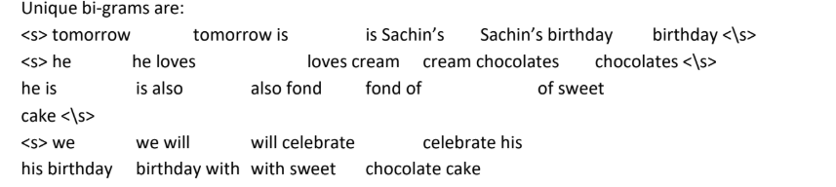

- Consider the following corpus C3 of 3 sentences.
there is a big garden
children play in a garden
they play inside beautiful garden
- Calculate P (they play in a big garden) assuming a bi-gram language model.
- Calculate the perplexity of <s> they play in a big garden<\s>
- Assume that you are using a bi-gram language model with one add smoothing. Calculate p(they play in a beautiful garden).
P(they | <s> ) = 1/3
P(play | they) = 1/1
P(in | play) = 1/2
P(a | in) = 1/1
P(big | a) = 1/2
P(garden | big) = 1/1
P(<\s>|garden) = 3/3
P(they play in a big garden) = 1/3 x 1/1 x 1/2 x 1/1 x 1/2 x 1/1 x 3/3 = 1/12
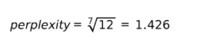
|V|=11
P(they | <s> ) = (1+1)/(3+11)
P(play | they) = (1+1)/(1+11)
P(in | play) = (1+1)/(2+11)
P(a | in) = (1+1)/(1+11)
P(beautiful | a) = (0+1)/(2+11)
P(garden | beautiful) = (1+1)/(1+11)
P(<\s>|garden) = (3+1)/(3+11)
P(they play in a beautiful garden) = 2/14 x 2/12 x 2/13 x 2/12 x 1/13 x 2/12 x 4/14

= 2.236 x 10^-6

- Given a corpus C2, the Maximum Likelihood Estimation (MLE) for the bigram “dried berries” is 0.45 and the count of occurrence of the word “dried” is 720. For the same corpus C2, the likelihood of “dried berries” after applying add-one smoothing is 0.05. What is the vocabulary size of C2?
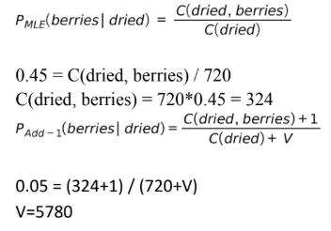

- Markov Chain Concept…Given that today the weather is sunny, what is the probability that tomorrow is sunny and day after is rainy?
- P(q2 = sunny;q3 = rainyI q1 = sunny)
- = P(q3 = rainyjq2 = sunny;q1 = sunny)P(q2 = sunnyIq1 = sunny)
- = P(q3 = rainyjq2 = sunny)P(q2 = sunnyIq1 = sunny)
- = 0.05 X 0.8
- = 0.04

- Let the rank of two words, w1 and w2, in a corpus be 1600 and 100, respectively. Let m1 and m2 represent the number of meanings of w1 and w2 respectively. What is the ratio of m1:m2?
Hint: m1/m2 = sqrt(rank2)/sqrt(rank1) = sqrt(100)/sqrt(1600) = 1:4

- Lets assume the probability of flipping heads two times in a row with a fair coin is q. Consider a sentence consisting of M random binary digits (0s and 1s). A model assigns probability to each digit in the sentence using the probability q. What is the perplexity of the sentence?
The probability of flipping heads two times in a row is q=1/2×1/2=1⁄4
Then perplexity is ((1/4)^M)^-1/M = 4

- Consider the HMM given below to solve the sequence labelling problem of POS tagging. With that HMM, calculate the probability that the sequence of words “free workers” will be assigned the following parts of speech;
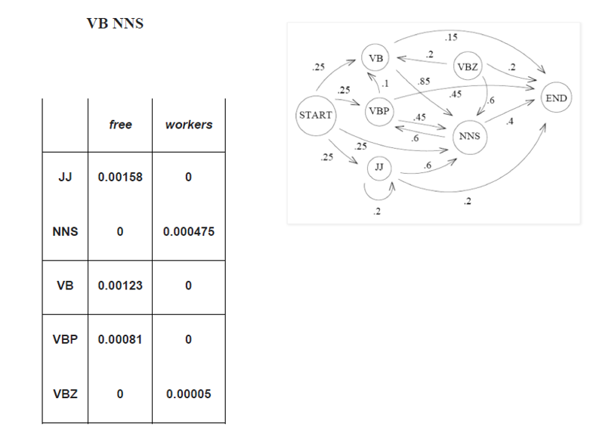

P(free workers, VB NNS)
= P(VB|start) * P(free|VB) * P(NNS|VB) * P(workers|NNS)
* P(end|NNS)
= 0.25 * 0.00123 * 0.85 * 0.000475 * 0.4
= 4.96 * 10-8

- Once a day (e.g. at noon), the weather is observed as one of state 1: rainy state 2: cloudy state 3: sunny The state transition probabilities are:
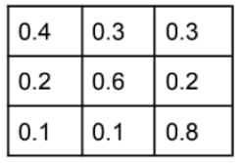
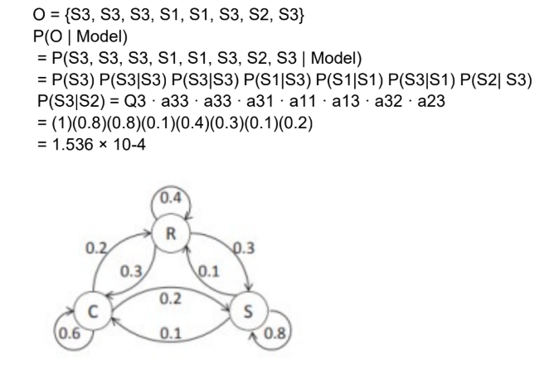
b) What is the expected number of consecutive days of sunny weather?
Exp(i) = 1/(1-pii) So for rainy, the expected no of days = 1/(1-0.8) = 5

12. Suppose you have the input sentence “Sachin is a great cricketer”. And you know the possible tags each of the words in the sentence can take
Sachin; NN, NNS, NNP, NNPS
is: VB
a: DT
great: ADJ
cricketer: NN, NNS, NNP
How many possible hidden state sequences are possible for the above sentence and states?

3 X 4
Solution: Each possible hidden sequence can take only one POS tag for each of the
words. Hence the total possibility will be a product of the number of candidates for
each word.

